- Where / how can we get the best shots on campus without masks?
- Clinician portraits all outdoors? Or natural light conference room?

Category | Name of Shot | Description of Shots |  |  | People | Location
Clinical | Acupuncture / Chinese Medicine | - Patient(s) receiving acupuncture  - Patient(s) receiving cupping  - Patient interaction with Clinician  - Chinese Herbs  - Portraits of clinicians |  |  | Alejandra Reyes  Fides Julian  Dong Ji  Doug Burr  Leng Tang-Ritchie  Jacqueline Arrellano | Outdoor or naturally lit exam room?
Clinical | Massage | - Patient receiving massage  - Close ups of hands giving massage  - Clinician and Patient wide shot  - Patient doing self-care/JSJ with and without clinician overseeing in shot?  - Clinician Portraits |  |  |  | Outdoor or naturally lit exam room?
Clinical | Osteopathic Manual Medicine (OMM) | - Patient receiving OMM  - Close ups of hands giving therapy  - Clinician and Patient wide shot  - Clinician Portraits |  |  | Alice Chen  Hollis King  Caitlin MacMillen | Outdoor or naturally lit exam room?
Clinical | IM Consults | - Patient-Clinician Interaction/Consultation, Holding hands, comforting, hand on shoulder (ALL)  - Demonstration of Yoga During Clinic Visit – physician doing yoga (MF)  - Acupuncture during Physician Visit (JS)  - Colorful food during Physician Consult (GS and DS)  - Clinician doing Telehealth Consult |  |  | Melanie Fiorella  Deepa Sannidhi  Jesse Sozanski  Ariel Portera  Dan Slater  Rusty Kallenberg  Gordon Saxe | Outdoor or naturally lit exam room?
Clinical | Nutrition and Cooking | - Patient-Clinician Interaction/Consultation  - Telehealth RD Consult  - Cooking/Food Prep  - Colorful vegetables  - Kitchen shots  - Portraits |  |  | Tiffany Holt  Anna Morrell  Brook Le’Amohala  Tasnim El-Mezain  Gordon Saxe  Lauray MacElhern | Kitchen
Clinical | Health Coaches | 1. Clinician on the Telephone  2. Clinician Telehealth Visit  3. Portraits |  |  | (Jessica Matthews)  Tasnim El Mezain  Ciana King | Natural light office
Clinical | Inpatient Treatments | - Treating patient(s) in hospital beds: Acupuncture, OMM (Osteopathic Manual Medicine), Massage  - Hospital “B-Roll” Shots |  |  | Erin Raskin  Alice Chen | Jacobs Medical Center
Clinical | TEAM | Picture of All Clinicians Together
 | TEAM | Picture of Clinicians Hugging 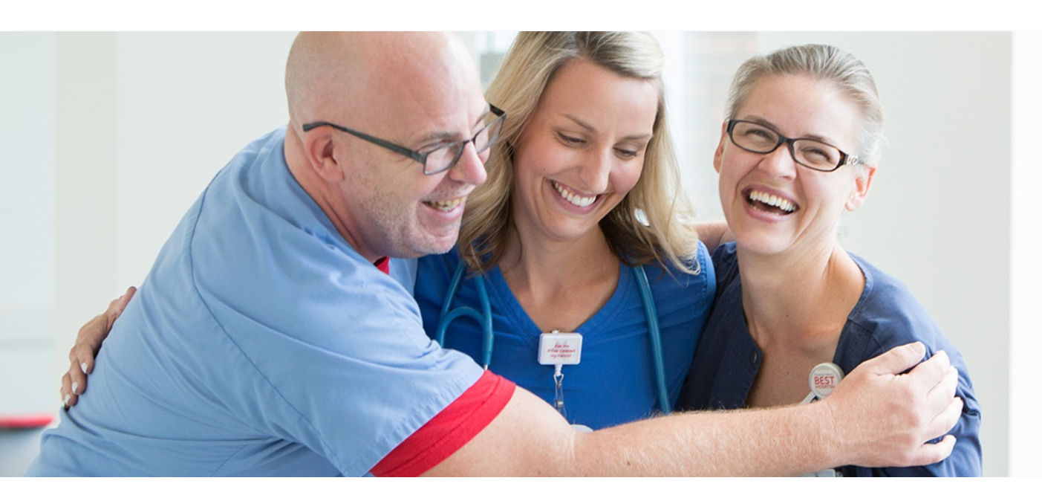
 | TEAM | Team holding thank you sign
Mindfulness | TEAM | Picture of All Center for Mindfulness Admin Team and Teachers |  |  |  | Outdoor, Nature
Mindfulness |  | Person meditating |  |  |  | Outdoor, Nature
Mindfulness |  | Clinician (white lab coat and stethoscope) meditating |  |  |  | Outdoor, Nature
Mindfulness |  | First Responder (in uniform) meditating |  |  | Joe Glaser-Reich  Anyone from La Mesa?
Mindfulness |  | Athletes meditating  Swimmer |  |  | Corey Falcon | Pool?
Mindfulness |  | Softball  https://ucsdtritons.com/news/2021/3/18/general-triton-mind-feature.aspx |  |  | Redshirt junior Bobbi Aguirre of the UC San Diego softball team | Field?
Mindfulness |  | Track and field shot  https://ucsdtritons.com/news/2021/3/18/general-triton-mind-feature.aspx |  |  | senior Delani Fish of Triton track and field | Field?
Mindfulness |  | Group sitting in a circle
Mindfulness |  | People holding hands
 |  | General shots to use for campaigns, banners etc.

